Upload Data to server

  - check for the server is server working or not

in browser enter http://serverip-address:server-port/apidocs

eg : http://10.0.90.13:3004/apidocs

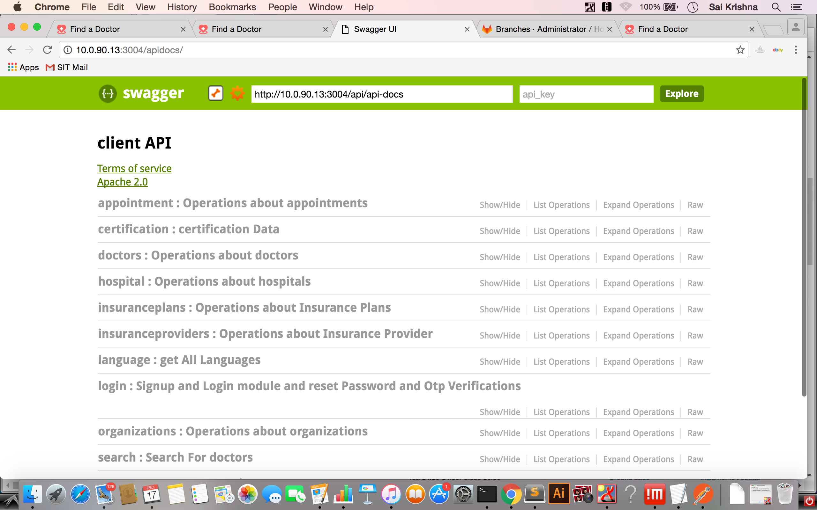

We will see a Swagger web page. which means server is up and running.

To push the data from local system to server we need to have node.js (4.4.2) installed in out local system.

Data Upload

Developer will send a zip file FADTools.zip which contains the script files to upload the data form the source csv files. unzip the FADTools and movie in to that folder.

after moving in to the FADTools folder.

We need to push data in the following order

upload LanguageData

To upload the languages data in to the server. inside the languagesSchemaParse.js file we need to replace the host ip and url with the our running nodes server ip address and port number.

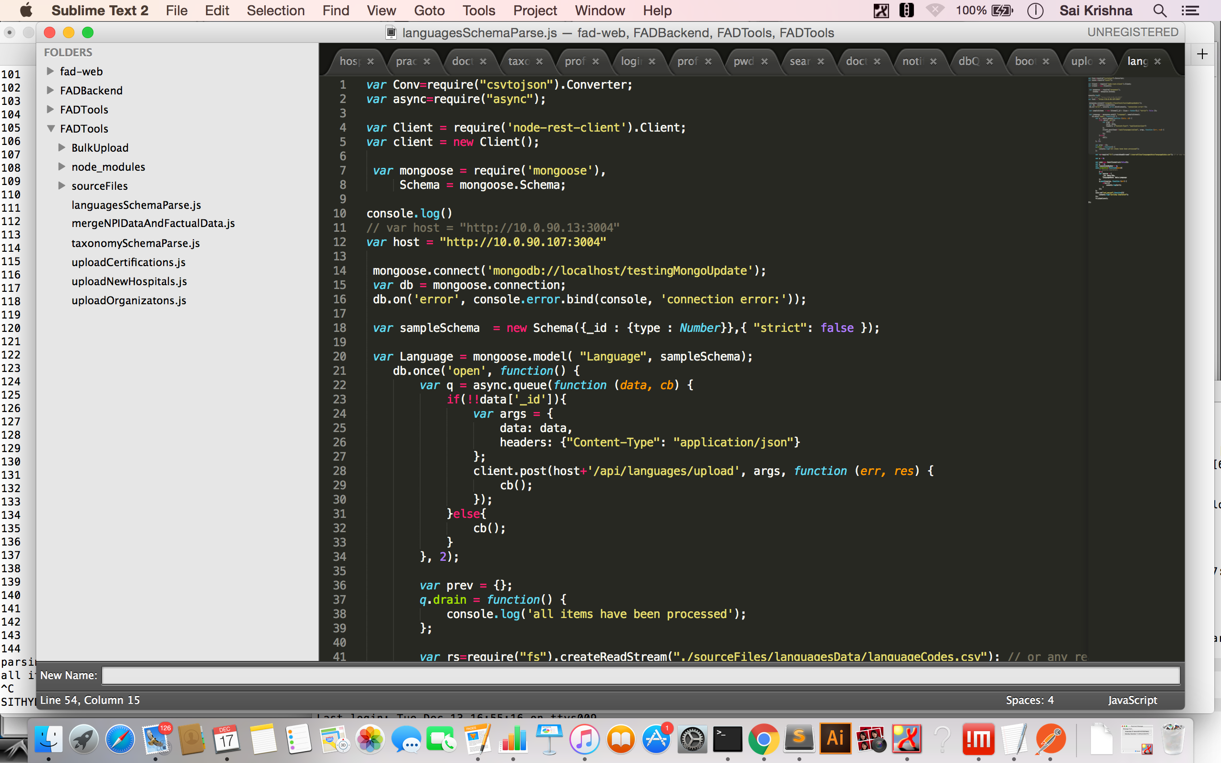

in the about image we need to replace var host = "http://10.0.90.107:3004" with var host = “http://x.x.x.x:p”

where x.x.x.x is server ip address and p is server port number.

in order to push the languages list we need to execute the following command.

node languagesSchemaParse.js.

To push the Taxonomies list.

Open taxonomySchemaParse.js file inside the FADTools folder and replace the host variable with server ip and port just as we did for languages.

To push the data we need to run the following command.

node taxonomySchemaParse.js

To Push the HospitalAffiliations List

Open uploadNewHospitals.js file inside the FADTools folder and replace the host variable with server ip and port just as we did for languages.

To push the data we need to run the following command.

node uploadNewHospitals.js

To Push the Certifications List

Open uploadCertifications.js file inside the FADTools folder and replace the host variable with server ip and port just as we did for languages.

To push the data we need to run the following command.

node uploadCertifications.js

To Push the Certifications List

Open uploadOrganizatons.js file inside the FADTools folder and replace the host variable with server ip and port just as we did for languages.

To push the data we need to run the following command.

node uploadOrganizatons.js

To Upload the DoctorData in to Mongo and ElasticSearch.

Open updloadNpiCaliforniaOnlyDoctorsToApp.js file inside the FADTools folder and replace the host variable with server ip and port.

Make sure elastic search, log stash are up and running.

To push the data to Mongodb and elastic search we need to run the following command.

node updloadNpiCaliforniaOnlyDoctorsToApp.js

To Upload the Factual DoctorData in to Mongo and ElasticSearch.

This step should be started only after completing the above step.

Factual data contains (Insurances , Hospital Affiliations etc)

Open mergeNPIDataAndFactualData.js file inside the FADTools folder and replace the host variable with server ip and port.

Make sure elastic search, log stash are up and running.

To push the data we need to run the following command.

node mergeNPIDataAndFactualData.js

